**CHAPTER-1**

**COMPANY PROFILE**

**EZ Trainings and Technologies Pvt. Ltd.**

**Introduction :**

EZ Trainings and Technologies Pvt. Ltd. is a dynamic and innovative organization dedicated to providing comprehensive training solutions and expert development services. Established with a vision to bridge the gap between academic learning and industry requirements, we specialize in college trainings for students, focusing on preparing them for successful placements. Additionally, we excel in undertaking development projects, leveraging cutting-edge technologies to bring ideas to life

**Mission:**

Our mission is to empower the next generation of professionals by imparting relevant skills and knowledge through specialized training programs. We strive to be a catalyst in the career growth of students and contribute to the technological advancement of businesses through our development projects.

**Services:**

**College Trainings:**

• Tailored training programs designed to enhance the employability of students.

• Industry-aligned curriculum covering technical and soft skills.

• Placement assistance and career guidance. Development

**Projects:**

• End-to-end development services, from ideation to execution.

• Expertise in diverse technologies and frameworks.

• Custom solutions to meet specific business needs

**Locations**: Hyderabad | Delhi NCR

At EZ Training and Technologies Pvt.Ltd., we believe in transforming potential into excellence.

**CHAPTER-2**

**ABSTRACT**

This code is an implementation of the Code Review System project in Python aims to provide a structured and efficient platform for managing code submissions and their review processes. The system allows developers to submit code, assigns reviews to other developers, tracks the status of reviews, and generates review statistics. This system is designed to enhance collaboration, streamline the review process, and maintain transparency in code evaluation.

**CHAPTER-3**

**INTRODUCTION**

In the fast-paced world of software development, ensuring the quality and reliability of code is paramount. Code reviews serve as a cornerstone in this process, offering a systematic approach to evaluating and enhancing the code base. To facilitate this critical aspect of collaboration, we introduce the Code Review System in Python.

This project is designed to provide a robust and user-friendly platform for managing the entire code review lifecycle. By leveraging the power of Python, the system offers developers a seamless experience in submitting code, assigning reviews, and tracking the status of their submissions. The project aims to address the challenges associated with collaborative code development, fostering transparency, accountability, and efficiency.

The system's functionalities, including code submission, review assignment, status updates, and deletion, contribute to a streamlined and organized code review process. The ability to generate review statistics enhances transparency, providing developers with insights into their review activities.

**CHAPTER-4**

**MODULE DESCRIPTION**

**Initialization**:

Initialize code_submissions and review_assignments lists in the CodeReviewSystem class.

**Code Submission:**

* Check if the given code_id already exists in code_submissions.
* If it exists, display an error message.
* If not, create a new submission with the provided details and append it to code_submissions.

Display a success message.

**Read Code Submissions:**

* Check if code_submissions is empty.
* If it is, display a message indicating there are no code submissions.
* If not, iterate through each submission and display its details.

**Assign Review:**

* Check if the given code_id exists in code_submissions.
* If not, display an error message.
* If it exists, assign a review by updating relevant fields in the corresponding submission.

Display a success message.

**Update Code:**

* Check if the given code_id exists in code_submissions.
* If not, display an error message.
* If it exists, check if the submission is assigned and open for review.
* If not, display an appropriate error message.
* If it is, update the code content, review status, and close timestamp.

Display a success message.

**Delete Code Submission:**

* Check if the given code_id exists in code_submissions.
* If not, display an error message.
* If it exists, remove the submission from code_submissions.

Display a success message.

**Generate Review Stats:**

* Iterate through code_submissions to find submissions associated with the given developer_id.
* Display the details of found submissions, including developer name, code ID, review status, assignment timestamp, open timestamp, and close timestamp.
* If no submissions are found, display a message indicating that.

**Review Code:**

* Check if the given code_id exists in code_submissions.
* If not, display an error message.
* If it exists, update the open timestamp and set the review status to "In Progress".
* Display the review ID, code content, and success m
* essage.

**CHAPTER-5**

**ALGORITHM**

Step 1: Start

Step 2: Initialize System

Initialize the CodeReviewSystem object with empty lists for code_submissions and review_assignments.

Step 3: Display Menu and Get User Choice

Step 4: Perform Action Based on User Choice

* + If the user's choice is 1: Call create_code_submission method.
  + If the user's choice is 2: Call read_code_submissions method.
  + If the user's choice is 3: Call update_code method.
  + If the user's choice is 4: Call delete_code_submission method.
  + If the user's choice is 5:Call assign_review method.
  + If the user's choice is 6:Call review_code method.
  + If the user's choice is 7:Call generate_review_stats method.
  + If the user's choice is 8:Display "Exiting Code Review System. Goodbye!"
  + End the program.

Step 5: Loop Back to Step 3

Repeat Steps 3-4 until the user chooses to exit.

Step 6: End

**CHAPTER-6**

**OUTPUT SCREENSHOTS**

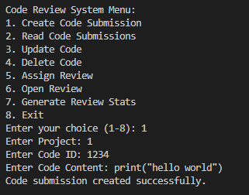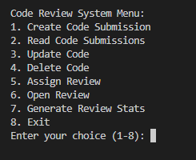

**Fig 1 : Menu driven Fig 2 : Create Code Submission**

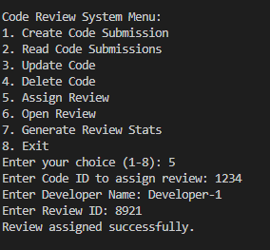

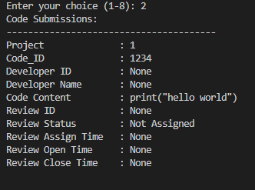

**Fig 3:Not Assigned Fig 4 : Assign Review**

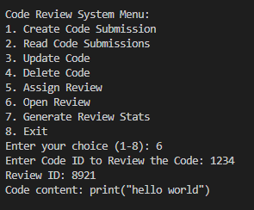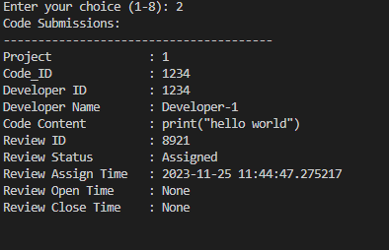

**Fig 5:Review status : Assigned Fig 6 : Open Review**

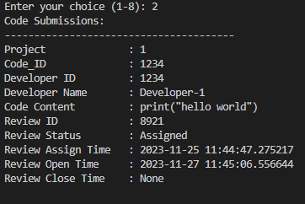

**Fig 7 : Assigned and Open Time of Code for Review**

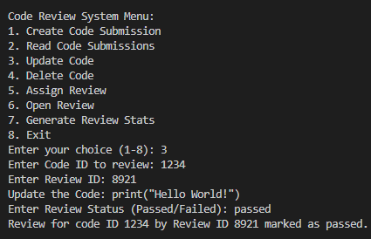

**Fig 8 : Update the code**

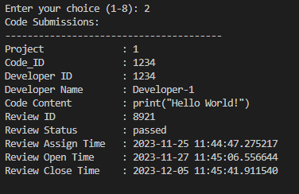

**Fig 9: Final Report of Code Review**

**CHAPTER-7**

**CONCLUSION**

The Code Review System in Python provides a comprehensive solution for managing code submissions and their review processes. The system allows developers to submit code, assigns reviews to other developers, tracks the status of reviews, and generates statistics. Through a menu-driven interface, users can seamlessly interact with the system, making it an effective tool for collaborative code development and evaluation. The project demonstrates effective use of Python's datetime module and provides a user-friendly interface for managing code reviews. As a result, the Code Review System facilitates a structured and efficient approach to code collaboration within a development team.

**CHAPTER-8**

**REFERENCES**

* [**https://blog.jetbrains.com/space/2021/12/15/best-code-review-tools/**](https://blog.jetbrains.com/space/2021/12/15/best-code-review-tools/)
* **https://en.wikipedia.org/wiki/List_of_tools_for_code_review**
* **https://google.github.io/eng-practices/review/reviewer/standard.html**